Date: 11 May 2010 Name: Whaea Jeanette
I am learning to create MPods (Memory Pods) that will help me think and recall facts about a particular topic.
X and Y axis Titles

Key
Graph Title
Graph

Typing up a Weebly Reflection Blog
Check for spelling and punctuation
Information relates to e-Learning work
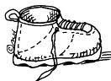
Reflective statement
Date of Blog

Tally Chart

